Lab 1 – The Basics of Qt

Aim: This lab will take you through all the steps required to build a fully fledged Qt application. The focus is to understand how a Qt application is structured and to learn to find your way round the Qt documentation.
Duration: 3 h

© 2011 Nokia Corporation and its Subsidiary(-ies).

The enclosed Qt Materials are provided under the Creative Commons Attribution-Share Alike 2.5 License Agreement.



The full license text is available here: http://creativecommons.org/licenses/by-sa/2.5/legalcode.

Nokia, Qt and the Nokia and Qt logos are the registered trademarks of Nokia Corporation in Finland and other countries worldwide.

Goals and Background
The goal of this lab is to apply the knowledge from the first lectures and put it in a context. The task at hand is to develop a fully fledged desktop application – a text editor with support for multiple documents, saving and loading, undoing, the clipboard, etc.
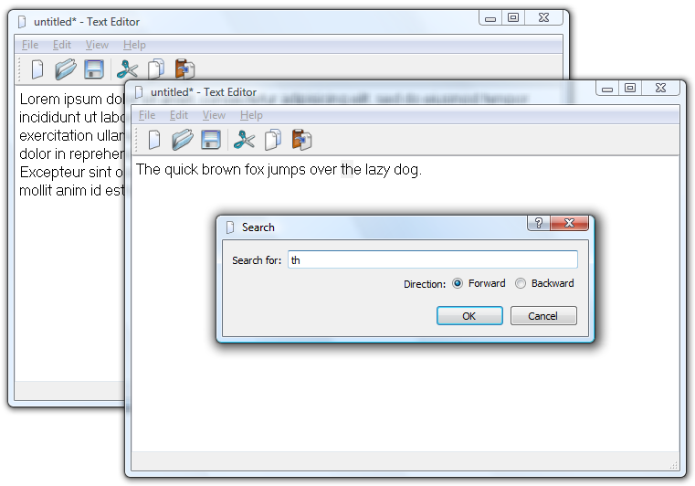
Throughout this lab, new features will be added to the application gradually. The purpose of this is twofold. First, this is how real world software is developed. The feature set grows over time. Secondly, you will have a working application from the very first step so that you can test, verify and debug the functionality continuously. Do not keep a known bug to a later step, make sure that the application works at all times. It will only be harder to properly troubleshoot in a more complex application.
In the lab, the instructions will be less detailed than in the exercises. This means that you are expected to look up classes in the Qt reference documentation, and that adding header files and other trivial code is up to you.

The Basic Application
The basic application is built from the Qt4 Gui Application template. Create such a project and include the QtCore and QtGui modules. Base the skeleton on the QMainWindow class. In this lab, the project is called TextEditor.
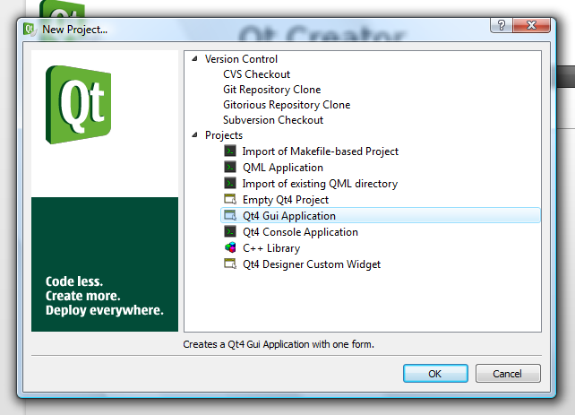
The resulting project consists of the following files:
- TextEditor.pro – the project definition file.
- mainwindow.ui – the user interface for the MainWindow class.
- mainwindow.cpp/h – the implementation and declaration of the MainWindow class.
- main.cpp – the main function. Gets everything initialized and started.
Review these files and verify that the project builds and runs.

Adding User Interface Elements
The next step is to add a QTextEdit widget and the basic user operations New, Close and Exit to the main window.
First of all, we need to add an icon resource to the project in question. This is because the icons will be used in the user interface which you are about to design.
Add a new Qt Resource file to the project. Name it icons.qrc. Open the resulting file, add the prefix icons and add the *.png files for this lab.
Now you are ready to start working on the user interface. Start by opening the mainwindow.ui file in Designer mode.

Add a QTextEdit widget to the main window and lay it out. Select the window itself to alter the margins of the layout to zero to get the new widget to fill the central area fully.
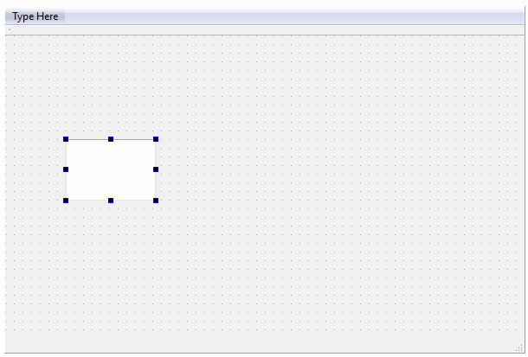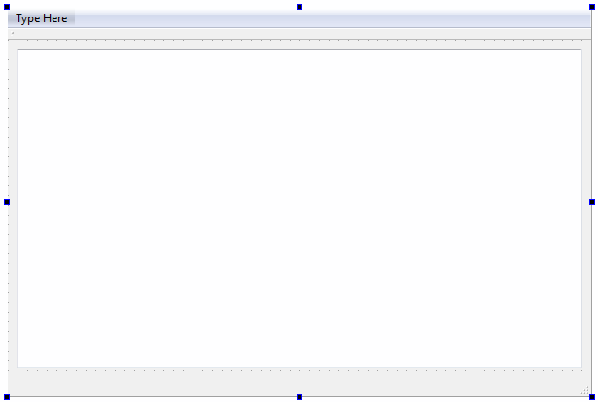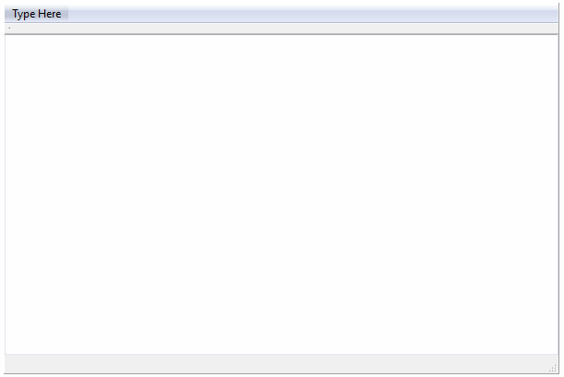
When the widget is in place you can try the dialog using Tools – Form Editor – Preview (Ctrl+Alt+R).
The user operations are represented by QAction objects. These are administered through the Action Editor shown below.
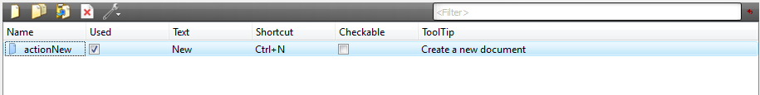
Create the following actions.
Text | Name | Icon | Shortcut | ToolTip
New | actionNew |  | Ctrl+N | Create a new document
Close | actionClose |  | Ctrl+W | Close current window
Exit | actionExit |  |  | Exit application

Actions are added to the user interface through drag and drop. Drag the actionNew action onto the toolbar.
Add the entry File to the menu bar. Click on the type here text and enter File. Now drag and drop the actionNew, actionClose and actionExit to the menu. Add separators between each item by dragging the separator into position (you find it on the menu you are editing).
If you enter “&File” as the title of the menu you get a shortcut, “File”, automatically. To get an ampersand in a menu text, enter “&&”.

Implementing Functionality
Each of the actions added need to be implemented. You do this by right clicking on the action in question to bring up its context menu. From the menu, pick the Go to slot option and pick the triggered() signal from the list that pops up.
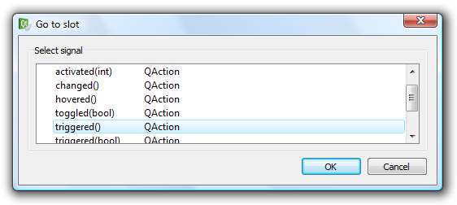
Start by implementing the actionNew, this brings you to the following source code.
void MainWindow::on_actionNew_triggered()
{

}
In this slot, create a new MainWindow object on the heap and show it.
The other two actions, actionClose and actionExit, already have matching slots implemented by Qt. Make the following connections in the MainWindow constructor, after the setupUi call.
Source | Signal | Destination | Slot
actionClose | triggered() | this (current window) | close()
actionExit | triggered() | qApp (current application) | closeAllWindows()

Also, make sure to call setAttribute and set the Qt::WA_DeleteOnClose attribute in the MainWindow constructor.

Self Check
- Ensure that you can open new windows.
- Ensure that File – Close closes the current window.
- Ensure that File – Exit closes all windows and thus terminates the application.
- Explain why the Qt::WA_DeleteOnClose attribute is set. Where does it come into play and why is that important?

Modifying and Closing
Now, the user can close a window with unsaved changes by mistake. That is not the expected behavior. Instead, the user expects to be prompted if risking to lose unsaved work. A two stage solution is needed to address this. First, the modified status of the document needs to be monitored. Second, the user must be prompted when trying to close a window with a modified document.
By monitoring the QTextEdit's textChanged signal document modifications can be tracked. Create a private slot called documentModified in your MainWindow class. In the constructor, connect the editor's signal to your slot. In the slot, set the windowModified property to true.
When reading the documentation, the windowModified property is not found in the QMainWindow class. Instead, it is defined in the QWidget class which QMainWindow inherits. You spot this by reading the properties section of QMainWindow, where “...properties inherited from QWidget” are mentioned.
The windowModified property interacts with the windowTitle property. For Mac OS X, the modified state is indicated by a dot in the window's red (left-most) button. On most other platforms, an asterisk in the title indicates that the document has been modified. This asterisk can be added to the windowTitle as “[*]”. Then Qt will synchronize the windowModified property and the windowTitle automatically.

To use this, set the windowTitle to “TextEditor[*]” in the MainWindow constructor and verify that modifications to the document triggers the document modified indication.
The other half of the solution is to prompt the user when the document is closed. This is done by re-implementing the protected closeEvent method of MainWindow. Start this by adding the function to your class declaration.
protected:
void closeEvent(QCloseEvent *e)
Then add an empty function body in your class implementation.
void MainWindow::closeEvent(QCloseEvent *e)
{

}

The event, e, can be accepted or ignored using e->accept() and e->ignore(). Implement the function so that the event is accepted for all unmodified documents. If the document is modified, use the QMessageBox::warning function to prompt the user and accept or ignore accordingly.
The warning method takes the following arguments (look in the documentation if you need the actual types).
QMessageBox::warning( parent widget,
dialog title, dialog text,
buttons to show, default button )
The dialog should show the QMessageBox::Yes and QMessageBox::No buttons, where No is default.
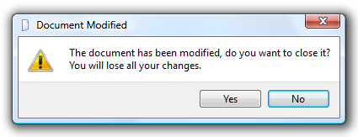
The return value from the function is the button clicked by the user – but as the user can close the dialog by closing its windows as well as clicking No, test for the Yes button.
Having implemented the close method, the File – Close and File – Exit menu actions should work as expected.

Self Check
- Ensure that the document modified indication (asterisk or dot in the red button) is triggered by modifying the document.
- Open a document, modify it, attempt to close the window using the following methods: the current window manager (i.e. click the “X” in Windows, etc), File – Close, File – Exit. Ensure that you are prompted.
- Ensure that when prompted, you can prevent the window from being closed by clicking No or rejecting the dialog in any other way (i.e. close it using the current window manager).
- Open a document, do not modify it, attempt to close the window using the methods above. Ensure that you are not prompted.
- Open several documents, modify some, activate File – Exit. Ensure that only modified windows are closed and that the entire closing procedure is canceled if you answer No when prompted.

Settings and Customization
Almost all applications available today have some sort of user settings. It can be everything from which measurement system to use, the preferred order of the toolbars, down to tuning very specific details. In this step we will let the user choose the font used for displaying the text document being edited.
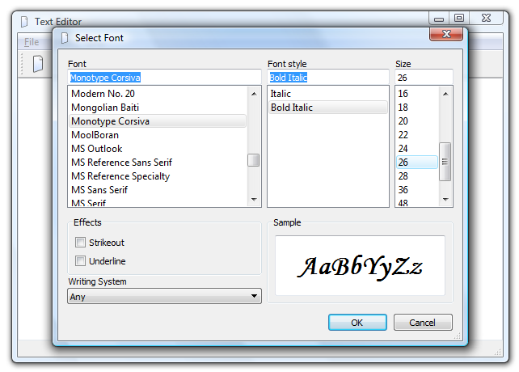
The setting will be stored using the platform's preferred method, i.e. the registry for Windows and hidden files for Linux, etc.

The Ground Work
It is possible to specify where to store settings and in which format in Qt, but a more convenient method is to set some basic properties to the QApplication object and then rely on QSettings' default behavior.
The required settings concern the application name and version, the (producing) organization's name and domain. Simply add the following code to your main function, where a is the QApplication instance.
a.setApplicationName("Text Editor");
a.setApplicationVersion("0.1");

a.setOrganizationName("ExampleSoft");
a.setOrganizationDomain("example.com");
While tweaking the properties of the QApplication object, set the windowIcon property to use the ":/icons/new.png" as icon.

Adding Actions
Add the following action to the main window.
Text | Name | Icon | Shortcut | ToolTip
Select Font... | actionSelectFont |  |  | Select the display font

Add the actions to a menu called View (you will have to create the menu in the menu bar).
Right click on the action and go to the slot for the triggered signal. The slot body will look like this.
void MainWindow::on_actionSelectFont_triggered()
{

}
In this slot, use the QFontDialog::getFont( *ok, initial, parent ) method to acquire a new QFont. Use the ui->textEdit->font() as the initial font. If the user accepted the dialog, i.e. ok is true, update the font property of ui->textEdit. Also, use a QSettings object to set the key “viewFont” to hold the current font as its value.
You can allocate the QSettings object on the stack, as the construction and destruction of the object is very fast and all its settings are acquired from the QApplication object.
Finally, to retrieve the stored font, use a QSettings object to set the font property of the ui->textEdit widget to the set value. Do this in the constructor of MainWindow, and use QApplication::font() as the default value for the setting.
The value from a QSettings object is a QVariant. Use the QVariant::value<T>() function, with T=QFont, to get the QFont from the QVariant.

Self Check
- Ensure that all windows have the new icon as window icon.
- Test that you can change the font of a given window.
- Test that you can cancel the font dialog.
- Change font and open a new window. Ensure that the new window gets the new font by default.
- Verify that the font selection is kept if you exit the application and relaunch it.

The Clipboard and Change History
Adding the expected clipboard operations Cut, Copy and Paste along with Undo and Redo is very simple. It is so simple that we will spend some extra time on adding an About dialog and more.
Most Qt widgets are prepared to be used in real world situations and provide interfaces to be easy to use. The QTextEdit widget is no exception to this. It provides slots for copy, cut, paste, undo and redo, as well as signals for enabling the different actions. Still, you need to add actions for all these operations and connect them.

Adding Actions
Start by adding the following actions to the main window
Text | Name | Icon | Shortcut | ToolTip
About | actionAbout
About Qt | actionAboutQt
Cut | actionCut |  | Ctrl+X | Cut
Copy | actionCopy |  | Ctrl+C | Copy
Paste | actionPaste |  | Ctrl+V | Paste
Undo | actionUndo |  | Ctrl+Z | Undo the last action
Redo | actionRedo |  | Ctrl+Y | Redo the last action

Place the About actions in a menu called Help (you will have to create the menu). Place the other actions in a menu called Edit (you will have to create the menu). Rearrange the menus of the menu bar by dragging and dropping so that the order is File, Edit, View and Help.
Add the clipboard actions to the toolbar as well. You can right click on the toolbar to add a separator between actionNew and the clipboard actions.

Implementing Functionality
All actions except About need only to be connected to work. This means that the functionality already is implemented by Qt.
In the constructor of the MainWindow class, make the following connections.
Source | Signal | Destination | Slot
actionAboutQt | triggered() | qApp | aboutQt()
actionCut | triggered() | textEdit | cut()
actionCopy | triggered() | textEdit | copy()
actionPaste | triggered() | textEdit | paste()
actionUndo | triggered() | textEdit | undo()
actionRedo | triggered() | textEdit | redo()
textEdit | copyAvailable(bool) | actionCopy | setEnabled(bool)
textEdit | copyAvailable(bool) | actionCut | setEnabled(bool)
textEdit | undoAvailable(bool) | actionUndo | setEnabled(bool)
textEdit | redoAvailable(bool) | actionRedo | setEnabled(bool)

The enabled properties of actionCopy, actionCut, actionUndo and actionRedo are updated by the corresponding QTextEdit signal. However, they are not initialized. In the constructor, add code to initialize them all with their enabled property set to false.
The only action left to react to is actionAbout. Right click on the action and go to the slot for the triggered signal. The slot body will look like this.
void MainWindow::on_actionAbout_triggered()
{

}
In the slot, use QMessageBox::about to show an about dialog for your application.

Self Check
- Check that Help – About shows an about dialog for your application.
- Check that Help – About Qt shows a dialog about the used Qt version.
- Check that Undo and Redo work as expected.
- Check that Undo and Redo are enabled as expected – even in a freshly started application.
- Check that Cut, Copy and Paste work as expected.
- Check that Cut and Copy are enabled as expected – even in a freshly started application.

File Operations
The biggest drawback with the text editor application is its lack of file operations. You cannot load documents, nor save them. In this section this will be addressed.
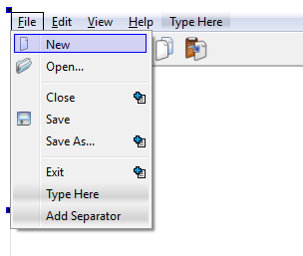
Saving and loading files has impact on other parts of the application as well. Each window must now have a file name, and the closeEvent must take the ability to save and close a document into account.

Loading Documents
Start by adding the private QString m_fileName to the MainWindow class declaration.
Modify the constructor of MainWindow to have the following signature.
MainWindow(const QString &fileName=QString(), QWidget *parent=0);
Finally, at the end of the constructor, add the line below.
loadFile(fileName);
As you understand, the task at hand is to build the loadFile method. Start by adding it as a private method of the MainWindow class. The method body should look like this.
void MainWindow::loadFile(const QString &fileName)
{

}
In this function, do the following:
- If the fileName is empty, call setFileName(QString()) (setFileName has not yet been implemented) and return.
- Create a QFile object for the file fileName.
- Attempt to open file QFile object for reading a text file, i.e. with the flags QIODevice::ReadOnly and QIODevice::Text.
- If the file cannot be opened, show an error message using QMessageBox::warning, call setFileName(QString()) and return.
- If the file is opened, create a QTextStream object working on the QFile object.
- Set the text property of the textEdit widget to the result of the readAll function of the QTextStream.
- Close the QFile object.
- Call setFileName(fileName).
- Set the windowModified property to false.
Now add the missing setFileName(const QString &) method as a private member of MainWindow. In it, assign m_fileName with the file name given and set the windowTitle property to the following string value.
QString("%1[*] - %2")
.arg(m_fileName.isNull()?"untitled":QFileInfo(m_fileName).fileName())
.arg(QApplication::applicationName())
Now, add the following action to the MainWindow user interface. Add the action to the toolbar and File menu.

Text | Name | Icon | Shortcut | ToolTip
Open... | actionOpen |  | Ctrl+O | Open a document

Go to the automatically generated slot for the triggered signal. The function body is shown below.
void MainWindow::on_actionOpen_triggered()
{

}
In the function, implement the following.
- Use the following function call to get a file name to open.
QString fileName = QFileDialog::getOpenFileName(this,
"Open document", QDir::currentPath(), "Text documents (*.txt)");
- If the file name isNull, return.
- If the current window's m_fileName isNull and the current document is unmodified, call loadFile(fileName), i.e. load the document into the current window.
- Otherwise, create a new QMainWindow(fileName) and show it, i.e. load the document into a new window.
Now experiment with this functionality. Open documents, create new documents and open from them, etc. Also close documents and ensure that the prompt only appears when applicable.

Saving Documents
Saving documents is slightly more complex than loading them. One half of this is that the user can Save or Save As, the other half is that it is important that the save succeeds and that failure is reported to the user.

Start the implementation of the save functionality by adding the following private slots to the MainWindow class declaration. Also, add some basic function bodies in the MainWindow implementation.
private slots:
bool saveFile();
bool saveFileAs();
As you can tell, both functions return a boolean. The idea is that true is returned if the file actually was saved and false if it failed. This is something that we will use later when re-implementing the handling of the user closing modified document.
The responsibilities of the two slots are that saveFile does the actual saving, while saveFileAs requests a new file name and then uses saveFile to save.
Start by implementing saveFileAs according to the flow described below.
- Use the following line to get a file name from the user.
QString fileName = QFileDialog::getSaveFileName(this, "Save document",
m_fileName.isNull()?QDir::currentPath():m_fileName, "Text documents (*.txt)");
- If the file name acquired isNull, return false, the file has not been saved.
- If the file name is valid, call setFileName to set the file name, then call saveFile. Return the value returned from saveFile.
The next step is to implement the saveFile slot. Implement the function as follows.
- If m_fileName isNull, call saveFileAs and return the value returned from that call.
- If m_fileName not isNull, create a QFile object for the file name.
- Attempt to open file QFile object for writing text files, i.e. with the flags QIODevice::WriteOnly and QIODevice::Text.
- If the QFile object could not be opened, use QMessageBox::warning to inform the user, call setFileName(QString()) and return false.
- If the QFile object opened, create a QTextStream object for the file.
- Write the textEdit->toPlainText() to the QTextStream.
- Close the QFile.
- Set the windowModified to false.
- Return true.
The functions saveFile and saveFileAs call each other. Explain how you guarantee that they do not get stuck in an infinite loop of calling each other.

Now, add the following actions to the MainWindow user interface. Add both to the File menu and actionSave to the toolbar.
Text | Name | Icon | Shortcut | ToolTip
Save | actionSave |  | Ctrl+S | Save document
Save As... | actionSaveAs |  | Ctrl+Shift+S | Save document as

In the constructor of MainWindow, connect these slots to the saveFile and saveFileAs slots.
Make sure to build and run the application. Experiment with the new functions. Ensure that documents can be loaded, saved and saved as. Also, ensure that the modified flag is turned on and off as expected and that the prompt on close is shown as expected.

Closing Windows
Right now, the user is asked whether to close or not to close a window with modified contents. The most common alternatives are 'discard changes and close', 'save changes and close' or 'do not close'. In order to achieve this, we must incorporate the file saving functionality in the closeEvent method.
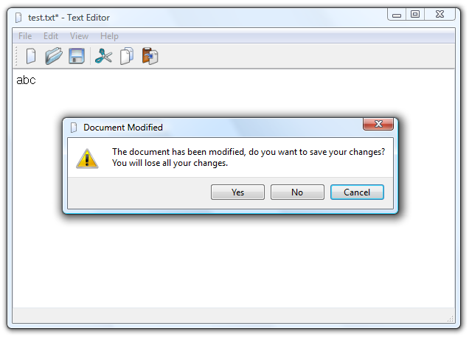

Start with the following closeEvent function body.
void MainWindow::closeEvent(QCloseEvent *e)
{
if(m_modified)
{
switch(QMessageBox::warning(this, "Document Modified",
"The document has been modified. "
"Do you want to save your changes?\n"
"You will lose and unsaved changes.",
QMessageBox::Yes | QMessageBox::No | QMessageBox::Cancel,
QMessageBox::Cancel))
{
case QMessageBox::Yes:
// [1]
break;
case QMessageBox::No:
// [2]
break;
case QMessageBox::Cancel:
// [3]
break;
}
}
else
{
// [4]
}
}
In the locations marked [1], [2], [3] and [4], ignore or accept the close event as appropriate. In one of the cases you need to call saveFile and ignore or accept depending on the success of the file saving operation.

Self Check
- Verify that you can load documents.
- Verify that you can save documents (and properly reload them).
- Verify that, when loading, saving and saving as, the window title is updated with the file name as expected.
- Verify that, when loading, saving and modifying documents, the windowModified state is updated as expected.
- Try closing a modified but unnamed document window. Ensure that you get to pick a file name when asking the application to save the changes.
- Try closing a modified but unnamed document window. Answer that you want to save your changes but cancel the file name picking dialog. Ensure that the window is not closed.

